Lab 7: Fourier Series
Objectives:
• Familiarizing students with periodic signals.
• Calculate the Fourier series of continuous and discrete time signals and plot the Fourier series coefficients.

Lab Tasks:
1. Consider the given function 𝑥(𝑡) where:
𝑥(𝑡) = 𝑡2 𝑓𝑜𝑟 − 1 ≤ 𝑡 ≤ 1
Calculate the Fourier series coefficients (𝑎𝑘 , 𝑏𝑘 and 𝑎0) using MATLAB. Use these coefficients
to approximate 𝑥(𝑡).
ANSWER:
syms t k;

% Define the function x(t) = t^2
x = t^2;

% Define the period T = 1
T = 1;

% Compute the a0 coefficient (mean value)
a0 = (1/T) * int(x, t, -1, 1);

% Compute the ak coefficient for k = 1, 2, 3, ...
ak = (2/T) * int(x * cos(k * pi * t / T), t, -1, 1);

% Compute the bk coefficient for k = 1, 2, 3, ...
bk = (2/T) * int(x * sin(k * pi * t / T), t, -1, 1);

% Display the Fourier coefficients a0, ak, and bk
disp(['a0 = ', char(a0)]);
disp(['ak = ', char(ak)]);
disp(['bk = ', char(bk)]);

% Fourier series approximation using the first 5 terms
x_approx = a0 / 2; % Start with a0/2
n_terms = 5; % Number of terms

for n = 1:n_terms
% Add terms for Fourier series
x_approx = x_approx + double(subs(ak, k, n)) * cos(n * pi * t) + double(subs(bk, k, n)) * sin(n * pi * t);
end

% Plot the original function and Fourier series approximation
fplot(x, [-1, 1], 'LineWidth', 2); hold on;
fplot(x_approx, [-1, 1], '--', 'LineWidth', 2);
legend('Original x(t)', 'Fourier Series Approximation');
title('Original Function and Fourier Series Approximation');
xlabel('t');
ylabel('x(t)');
grid on;

RESULT:
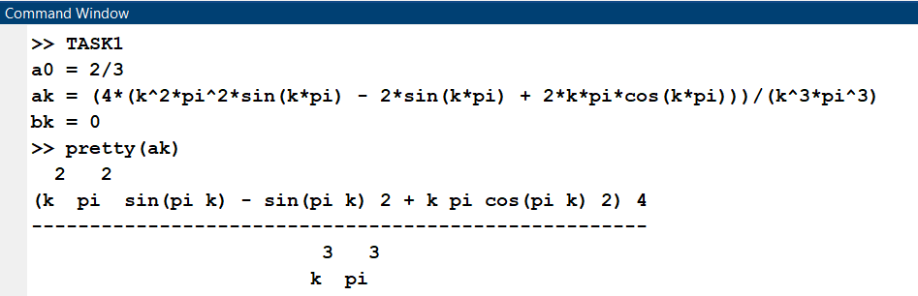
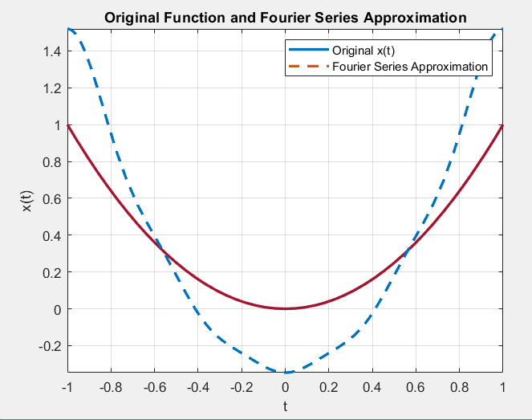
2. Approximate the square wave using Fourier Series Coefficients and plot the approximations by using 1, 3, 9, 21, 49, 71, 121, 211 & 516 coefficients.
ANSWER
% Define the time variable
t = linspace(-1, 1, 1000); % Time interval from -1 to 1
% Define the square wave function (periodic square wave)
square_wave = @(t) sign(sin(pi * t)); % Square wave with period 2
% Fourier Series approximation
% Initialize the figure
figure;
hold on;
% Plot the original square wave
plot(t, square_wave(t), 'k', 'LineWidth', 2, 'DisplayName', 'Original Square Wave');
% List of number of terms to use in the approximation
terms = [1, 3, 9, 21, 49, 71, 121, 211, 516];
% Loop through each number of terms
for n_terms = terms
% Initialize the Fourier series approximation
approximation = zeros(size(t));
% Sum the Fourier series up to n_terms
for k = 1:n_terms
if mod(k, 2) == 1 % Only odd harmonics (1, 3, 5, ...)
approximation = approximation + (4 / (pi * k)) * sin(pi * k * t);
end
end
% Plot the approximation
plot(t, approximation, 'LineWidth', 1.5, 'DisplayName', ['N = ', num2str(n_terms)]);
end
% Add labels and legend
xlabel('t');
ylabel('Amplitude');
title('Square Wave Approximation using Fourier Series');
legend('show');
grid on;
hold off;

RESULT

